**Lesson Notes**

1. What is the main purpose of an Operating System?

* Simpler / More Efficient Application Programs
  + Operating System handles the Computer Hardware
  + Operating System handles resource allocation
* Consistent User Experience
  + Operating System provides a standard User Interface (Windows)
  + Operating System provides a standard way to store and browse data files and folders (File Explorer)
* Allow Multiple Applications Running At Same Time
  + Operating System Provides Ownership Control (User Accounts)
  + Operating System Schedules the CPU (Task Sharing)

1. What is the difference between Operating System Software and Use Application Software?

* Hardware Independence
  + Same applications can run on different computer hardware
  + Operating System must be configured according to hardware components present in the computer
* User Interface
  + Applications focus on what is contained and displayed within a window
  + Operating System controls opening / closing / resizing windows and responding to mouse and keyboard actions
  + Operating System provides standard ways to print, save and open files, access the internet, etc.
* Resource Allocation
  + Applications just ask for what they need (e.g. Memory, Disk Space)
  + Operating System checks for availability and access permission
  + Operating System coordinates resource allocation between applications

1. What is the difference between Operating System Software and Computer Hardware?

An operating system is system software that manages computer hardware, software resources, and provides common services for computer programs.

1. What are the main parts of an Operating System?

* Graphical User Interface (GUI)
  + Windows Display, mouse, keyboard, sound, etc.
* System Calls
* Device Drivers
* I/O Manager
* Memory Manager
* Process Manager
* Security Monitor

1. What are some popular operating systems?

* Windows OS
* Mac OS
* Linux / Unix
* Android
* iOS

**Reference Diagram**

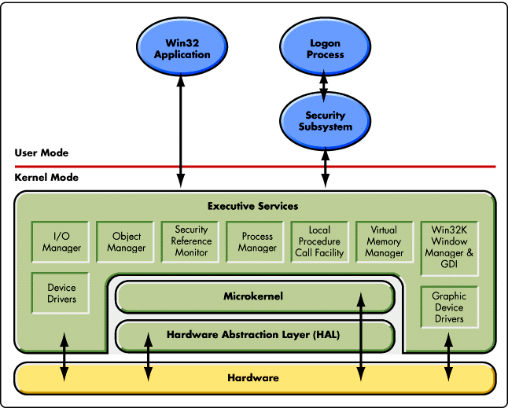

**Student Questions**

1. What is a device driver?
   1. Provide a brief summary

A device driver is a computer program that operates or controls a particular type of device that is attached to a computer.

* 1. List some devices that require a device driver.

Printers, displays, CD-ROM readers, network or sound cards, computer mice or hard disks

* 1. Provide a label on the reference diagram for the location of a device driver for your graphics card.
  2. Provide a label on the reference diagram for the location of a device driver for a locally attached printer.

1. What is a DLL?
   1. Provide a brief summary

Dynamic-link library is Microsoft's implementation of the shared library concept in the Microsoft Windows and OS/2 operating systems. These libraries usually have the file extension DLL, OCX, or DRV.

* 1. Explain how DLLs are related to user application programs

Some devices include printers, displays, CD-ROM readers, network or

sound cards, computer mice or hard disks.

* 1. Provide a label on the reference diagram for the location of a DLL

1. What is a windows manager?
   1. Provide a brief summary

A window manager is system software that controls the placement and appearance of windows within a windowing system in a graphical user interface

* 1. Explain how a windows manager is related to user application programs

Most window managers are designed to help provide a desktop

environment. They work in conjunction with the underlying graphical

system that provides required functionality—support for graphics hardware, pointing devices, and a keyboard, and are often written and

created using a widget toolkit.

* 1. Provide a label on the reference diagram for the location of a DLL

1. What is the windows task manager?
   1. Provide a brief summary

The windows task manager is a is a task manager, system monitor, and startup manager included with Microsoft Windows systems

* 1. List and explain four (4) types of system information provided by the task manager

1. Users
2. Details
3. App history
4. Performance
   1. Provide a label on the reference diagram for the operating system components related to each type of information.